

Linux Desktop Testing Project – LDTP
http://ldtp.freedesktop.org
Tutorial

Copyright 2004 - 2007 Novell, Inc.

Permission is granted to copy, distribute and/or modify this document
under the terms of the GNU Lesser General Public License, Version 2
or any later version published by the Free Software Foundation;
with no Invariant Sections, no Front-Cover Texts, and no Back-Cover Texts.
A copy of the license is included in the section entitled "GNU
Lesser General Public License".

You should have received a copy of the GNU GNU Lesser General Public
License along with this documentation; if not, write to the
Free Software Foundation, Inc., 59 Temple Place - Suite 330,
Boston, MA 02111-1307, USA.

Author
Nagappan A <nagappan@gmail.com>
Contributors:
Harsha <nharsha@gmail.com>
Premkumar J <prem.jothimani@gmail.com>
Guofu Xu <lavixu@gmail.com>
Surendran M <suren.silverprince@gmail.com>
Vamsi B <vamsi1985@gmail.com>

Table of Contents
About LDTP 5
Audience 5
About testing 5
Why testing ? 5
Complexity of GUI testing ? 6
What type of testing can be done using LDTP ? 6
Advantage of accessibility based testing 6
Disadvantage of accessibility based testing 6
What all applications can be tested ? 6
Supported platforms 6
LDTP Features 6
Web / Contact 7
LDTP on web 7
Development mailing list 7
Internet relay chatting – IRC 7
Architecture 7
LDTP Overall Architecture 7
LDTP Internals 7
Server 8
Client Handler 8
Component Handler 8
Event Handler 9
Logger 9
LDTP conventions 9
Appmap 9
Appmap convention 9
How to Access UI Objects from LDTP scripts 11
Window name 11
Glob pattern support 12
Different ways of representing window name 12
Object name 12
Label 12
Example 12
Label by / Label for (associated label) 12
Example 12
Object name with out label / associated label accessing via index 13
Example 13
Object name with index 13
Example 13
Window name format 13
Example 13
Object name format 13
Example 13
System requirements 14
Disk space requirement 14
Software requirements 14
Environment 14
Setup LDTP 14
Download source from CVS 14
Download source from CVS 14
Setup LDTP from source in Linux environment 14
Setup LDTP from binary 14
Accessibility library 15
Enable accessibility 15
Using / Hacking LDTP 16
Identifying controls 16
Push button 16
Menu item 17
Toggle button 18
Text control 19
Table control 20
Push button 21
Check box 22
Spin button 24
Page tab 25
Check menu item 25
Radio menu item 28
Combo box – Menu item 29
Combo box – List item 30
Launch application 32
GUI exist 33
Timeout 33
Re-Initialize LDTP 34
Set context / Release context 35
Generate raw keyboard events 35
Callback – On new window creation 37
Advantage 37
Example 37
Logging 38
Example script 38
Script input Data XML file - Useful to maintain a generic script 39
What 39
Why 39
Advantages of using LDTP Data XML 39
LDTP Data XML Tags 39
Syntax 40
Example 40
Sample XML File 40
Sequencing set of LDTP scripts using ldtprunner XML file 40
What 40
Why 40
Advantages of using ldtprunner XML 40
ldtprunner Tags 41
Sample LDTP runner XML file 41
How to execute LDTP scripts 42
Suggestions from LDTP team 42
How to operate LDTP from a remote system 43
LDTP engine 43
LDTP client 43
Troubleshooting LDTP 43
Sample LDTP script / runner XML / log XML 44
LDTP runner input XML file 44
Test script 44
XML Log file, On success 44
XML Log file, On failure 45
Bibliography 45

About LDTP
Linux Desktop Testing Project (LDTP) is aimed at producing high quality test automation framework and cutting-edge tools that can be used to test GNU/Linux Desktop and improve it. It uses the Accessibility libraries to poke through the application's user interface. The framework also has tools to record test-cases based on user-selection on the application.
LDTP core framework uses Appmap (application map) and the recorded test-cases to test an application and gives the status of each test-case as output. As of now, LDTP can test any GNOME application which are accessibility enabled, Mozilla, Openoffice.org, any Java application (should have a UI based on swing) and KDE 4.0 applications based on QT 4.0 (based on the press releases by KDE).
We encourage you to join the project and help us to create robust, reliable and stable test tool / framework for Unix Desktops. Thanks to GNOME Accessibility team and Sun Microsystems Accessibility team for their great work and their continuous support !!!

Audience
Its assumed that the user of this document has little knowledge about UI controls in any GUI application, minimal Linux or Unix (Solaris / BSD flavor) knowledge.

About testing

Why testing ?
Testing is a process to identify defects in a (software) system. For more information - http://en.wikipedia.org/wiki/Software_testing
Why automation ?

Complexity of GUI testing ?
- Identification of object in a window (push button, menu item)
- Should be context sensitive (Window specific operation)
- Handling of unexpected pop-up windows
- Keeping the test script in sync with the UI changes
- Failures has to be verified on each operation
- Rendering of images / text in the display area

What type of testing can be done using LDTP ?
LDTP can be used to test the functionality of any accessibility enabled application.

Advantage of accessibility based testing
- Accessibility libraries provide applications property, state, its child items etc.
- No need to work in toolkit (GTK, AWT, QT) level

Disadvantage of accessibility based testing
- Application which are not accessibility enabled can't be tested

What all applications can be tested ?
As of now, LDTP can test any GNOME application which are accessibility enabled, Mozilla, Openoffice.org, any Java application (should have a UI based on swing) and KDE 4.0 applications based on QT 4.0 (based on the press releases by KDE).

Supported platforms
- OpenSuSE
- OpenSolaris
- Debian
- Ubuntu
- Fedora
- FreeBSD

LDTP Features
- LDTP concepts are derived from Software Automation Framework Support
- LDTP supports verification of actions performed (guiexist, verifystate, etc) - API Reference
- Writing test scripts are very easy, the script writer need not know about the object hierarchy
- CPU / Memory performance monitoring of application-under-test can be measured - Class pstats
- From the XML log, we can gather HTML report using XSLT
- Group based execution, which provides precise control on the flow of test-script execution - ldtprunner XML
- Scripts can be written as a reusable component and for that the data can be stored / retrieved in XML - Data XML
- Objects are identified both statically and dynamically

Web / Contact

LDTP on web
- Website - http://ldtp.freedesktop.org
- Source / Binary - http://ldtp.freedesktop.org/wiki/Download
- API reference - http://ldtp.freedesktop.org/wiki/Docs
- HOWTO - http://ldtp.freedesktop.org/wiki/HOWTO
- FAQ - http://ldtp.freedesktop.org/wiki/FAQ

Development mailing list
http://lists.freedesktop.org/mailman/listinfo/ldtp-dev

Internet relay chatting – IRC
#ldtp of irc.freenod.net

Architecture

LDTP Overall Architecture

Test scripts uses LDTP API interface, which in-turn communicate to LDTP engine either by UNIX socket or by TCP socket. LDTP engine talks to Application under test (AUT) using AT-SPI library.

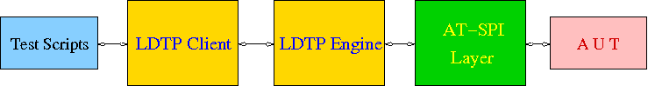

LDTP Internals
LDTP Clients can talk to LDTP engine with the set of LDTP Command Transfer Protocol (LDTPCTP) as defined in the Docs section. LDTP client wraps the LDTP Command Transfer Protcol based on the programming language (example: separate python client, maybe in future we can have Mono / Java / Perl based clients). Communication between the client and server takes place in XML format.

Most of LDTP ideas are implemented from http://safsdev.sf.net Most of the commands takes at-least 2 arguments. First argument will be context (window in which we want to operate) and the second argument will be component (object in which we want to operate, based on the current context).

Example: click ('*-gedit', 'btnNew') # Click operation will be performed on a window which is having *-gedit (regexp) and in that window object name 'New', which is of type 'push button'.

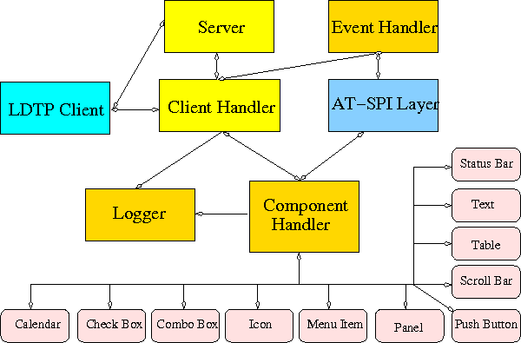

Server
When a test script is started, the LDTP client will establish a connection with the LDTP engine using AF_UNIX / AF_INET.

Client Handler
When ever a command is executed from the script, the client frames the XML data and send it to the server. LDTP engine parses the command request from the client and invoke the respective Component Handler.

Component Handler
Each individual component handlers uses the AT-SPI libraries to communicate to the respective application. Based on the execution status, success or failure will be notified as a response (in XML format) to the client. In few cases the requested data from the respective component will be returned to the client, based on the request (example: gettextvalue).

Event Handler
For unexpected windows (example: connection reset by peer /connection timed out dialogs) can be handled by registering a callback function and the respective callback function will be called, whenever the registered window with the title appears and even this window could be based on regular expression.

Logger
Logs the execution status in XML format

LDTP conventions

Appmap
'Appmap' [Application Map in short] is a text based representation of the GUI which is under testing. Each and every UI control viz., Button, Text Box etc., are represented using predefined conventions (which are listed in the table below) along with their parent UI object information. At runtime, a particular UI control is accessed by using the Appmap generated for the GUI under testing. For more details about Appmap refer http://safsdev.sourceforge.net/DataDrivenTestAutomationFrameworks.htm#TheApplicationMap

Appmap convention

Class keywords | convention used in appmap
ACCEL_LABEL
ALERT | dlg
ANIMATION
ARROW
CALENDAR | cal
CANVAS | cnvs
CHECK_BOX | chk
CHECK_MENU_ITEM | mnu
COLOR_CHOOSER
COLUMN_HEADER
COMBO_BOX | cbo
DATE_EDITOR
DESKTOP_ICON
DESKTOP_FRAME | frm
DIAL | dial
DIALOG | dlg
DIRECTORY_PANE
DRAWING_AREA | dwg
FILE_CHOOSER | dlg
FILLER | flr
FONT_CHOOSER | dlg
FRAME | frm
GLASS_PANE
HTML_CONTAINER | html
ICON | ico
IMAGE | img
INTERNAL_FRAME
LABEL | lbl
LAYERED_PANE | pane
LIST | lst
LIST_ITEM | lsti
MENU | mnu
MENU_BAR | mbar
MENU_ITEM | mnu
OPTION_PANE | opan
PAGE_TAB | ptab
PAGE_TAB_LIST | ptl
PANEL | pnl
PASSWORD_TEXT | txt
POPUP_MENU | pop
PROGRESS_BAR | pbar
PUSH_BUTTON | btn
RADIO_BUTTON | rbtn
RADIO_MENU_ITEM | mnu
ROOT_PANE | rpan
ROW_HEADER | rhdr
SCROLL_BAR | scbr
SCROLL_PANE | scpn
SEPARATOR | sep
SLIDER | sldr
SPIN_BUTTON | sbtn
SPLIT_PANE | splt
STATUS_BAR | stat
TABLE | tbl
TABLE_CELL | tbl
TABLE_COLUMN_HEADER | tch
TABLE_ROW_HEADER | trh
TEAROFF_MENU_ITEM | tmi
TERMINAL | term
TEXT | txt
TOGGLE_BUTTON | tbtn
TOOL_BAR | tbar
TOOL_TIP | ttip
TREE | tree
TREE_TABLE | ttbl
UNKNOWN | unk
VIEWPORT | view
WINDOW | dlg
EXTENDED
HEADER | hdr
FOOTER | foot
PARAGRAPH | para
RULER | rul
APPLICATION | app
AUTOCOMPLETE | txt
CALENDARVIEW | cal
CALENDAREVENT | cal
EDITBAR | txt
ENTRY | txt

How to Access UI Objects from LDTP scripts
Two main entities to act on an object, window name, object name.

Window name
To operate on a window, we need to know the window name (nothing but window title).

Different window types
- Frame (frm)
- Dialog (dlg)
- Alert (dlg)
- Font Chooser (dlg)
- File Chooser (dlg)
- Window (This type in general does not have any associated title, so we need to represent them using index - dlg)

Glob pattern support
Window name can be clubbed with glob patterns (* or ?)

Different ways of representing window name
- Window type and window title (Ex: 'frmUnsavedDocument1-gedit')
- Window title (Ex: 'Unsaved Document 1 - gedit')
- Window type, glob expression and partial window title (Ex: 'frm*-gedit')
- Glob pattern and partial window title (Ex: '*-gedit')
- Window type, partial window title and glob pattern (Ex: 'frmUnsavedDocument1*')
- Window type, window title and index (If two windows of same title exist at same time. Ex: First window name 'dlgAppoinment', Second window name 'dlgAppoinment1')
- Window type and index (only if window does not have any accessible title, Ex: 'dlg0')

Object name
Object (the type of control in which we want to operate) can be identified either with a label or by an associated label.

Label
In general menu / menu item / push button / toggle button type controls can be accessed through its label.

Example
mnuFile (gedit menu)
mnuNew (gedit menu item)
btnNew (gedit tool bar, push button)
tbtnLocation (gedit Open File dialog, toggle bar control)

Label by / Label for (associated label)
In general text / tables / check box / radio button / spin button / combo box controls can be accessed using the associated label only.

Example
txtLocation (gedit Open File dialog, text control)
tblFiles (gedit Open File dialog, table control)
cboSearchfor (gedit Find dialog, combo box control)
chkMatchcase (gedit Find dialog, check box control)
sbtnRightmarginatcolumn (gedit Preferences dialog, spin button control)

Object name with out label / associated label accessing via index
If a control does not have any label or associated label, then it can be accessed using index.

Example
txt0 (gedit text rendering region)
ptl0 (gedit Preferences dialog, page tab list control)
ptl0 (In gedit when more than one files are opened, a page tab list control will be available)

Object name with index
In some cases, a control type can be present in multiple places in the same window and chances that it may have same label too in that case, the first control can be accessed just with the default notation, but the second control and further can be accessed with the format control type, label or associated label and index starting from 1.

Example
btnAdd – First push button control with label Add
btnAdd1 – Second push button control with label Add
btnAdd2 – Third push button control with label Add

Window name format
If window label contains space or new line characters, they will be stripped.

Example
'Unsaved Document 1 – gedit', will be represented as 'UnsavedDocument1-gedit'

'Unsaved Document 1
-
gedit', will be represented as 'UnsavedDocument1-gedit'

Object name format
If object label or associated label contains space, dot, colon, under score or new line characters, they will be stripped.

Example
'Search for:' will be represented as 'Searchfor'

'File name 'a_txt' already exist.
Replace' will be represented as 'Filename'atxt'alreadyexistReplace'.

System requirements

Disk space requirement
Less than 1.0 MB

Software requirements
Install the following dependency development packages
- cspi-1.0 development library >= 1.2.0, glib-2.0 >= 2.2.0, gobject-2.0 >= 2.2.0
- gail-devel
- libgail-devel (or libgail-gnome based on your distribution)
- python-devel
- libxml-2.0 >= 2.0.0
Optional packages (to be installed)
- Import tool of ImageMagick - To capture a screenshot
- Python Imaging Library - Compare images, black out a region in an image
- pystatgrab - CPU / Memory utilization monitoring library
- Linux Test For X - LTFX, To operate on Window / Object which is not accessibility enabled

Environment
GNOME 2.10 or above / KDE 4.0 or above

Setup LDTP

Download source from CVS
- check out source from CVS with the following command: 'cvs -d:pserver:anoncvs@cvs.freedesktop.org:/cvs/ldtp co ldtp'.
- change to the source directory with the following command: 'cd ldtp'

Download source in tar ball format
- If you can't access CVS, get the source tarball from http://ldtp.freedesktop.org/wiki/Download
- change to the source directory with the following command: 'cd ldtp-<version number>'

Setup LDTP from source in Linux environment
- build with './autogen.sh --prefix=/usr; make' Assuming that all the above mentioned development packages are installed. (If downloaded tarball, './configure --prefix=/usr; make')
- setup with 'make install' as the root user

Setup LDTP from binary

Download latest RPM / Deb / Gentoo / Solaris package from http://ldtp.freedesktop.org/wiki/Download

Accessibility library
LDTP uses accessibility libraries (at-spi) available in GNOME environment. Using accessibility we can get the information about application and its current state (property). We can be able to poke through each layer in any application, if and only if, the application is accessibility enabled.

Enable accessibility
In gnome-control-center, open Assistive Technology.

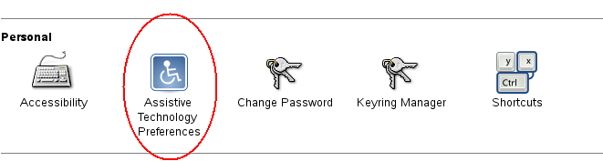Drawing 1: Assistive technology preferences under GNOME control center
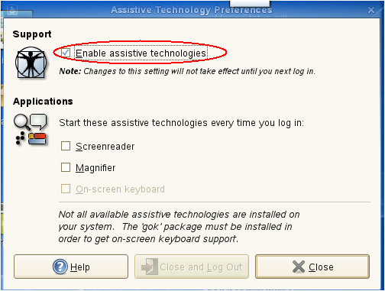Drawing 2: Screenshot of Assisstive technology preferences dialog

Using / Hacking LDTP

Identifying controls
To operate on a window, first thing we need to know is the window title.

In the following picture you could notice red colored eclipse mark is the window title.

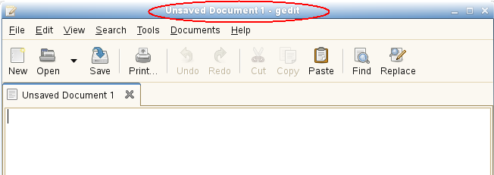

nags@nags:~> python
Python 2.5 (r25:51908, Nov 25 2006, 15:39:45)
[GCC 4.1.2 20061115 (prerelease) (SUSE Linux)] on linux2
Type "help", "copyright", "credits" or "license" for more information.
>>> from ldtp import *
>>> guiexist ('*-gedit')
1
>>> guiexist ('frmUnsavedDocument1-gedit')
1
>>> guiexist ('frmUnsavedDocument1-*')
1
>>> guiexist ('frm*-gedit')
1
>>> guiexist ('Unsaved Document 1 - gedit')
1
>>>

Push button
To operate on an object inside gedit window, we need to know the object information.

To click on open push button in gedit tool bar control, we need to use click API with window name as first argument and object name as second argument. The above command does the click operation. Informations to be gathered are Window name (Unsaved Document 1 – gedit) and push button control (Open).

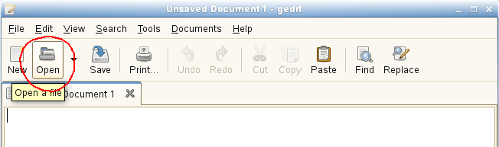

nags@nags:~> python
Python 2.5 (r25:51908, Nov 25 2006, 15:39:45)
[GCC 4.1.2 20061115 (prerelease) (SUSE Linux)] on linux2
Type "help", "copyright", "credits" or "license" for more information.
>>> from ldtp import *
>>> click ('*-gedit', 'btnOpen')
1
>>>

Menu item
To select a menu item under a menu in a window we need to use selectmenuitem API.

Informations to be gathered: Window name (Unsaved Document 1 – gedit), menu control (File), menu item control (New).

Incase of menu, we handle them in hierarchy. So, to access 'New' menu item, we need 'File' menu control too.

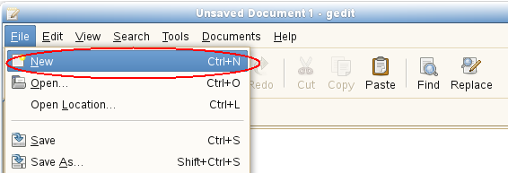

nags@nags:~> python
Python 2.5 (r25:51908, Nov 25 2006, 15:39:45)
[GCC 4.1.2 20061115 (prerelease) (SUSE Linux)] on linux2
Type "help", "copyright", "credits" or "license" for more information.
>>> from ldtp import *
>>> selectmenuitem ('*-gedit', 'mnuFile;mnuNew')
1
>>>

Toggle button
To operate on a toggle button with a click action, information required are window name (Open Files...) toggle button control (Type a file name).
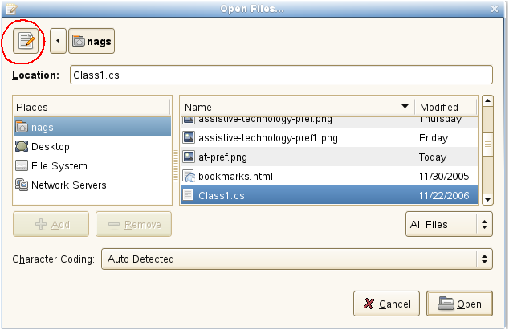

nags@nags:~> python
Python 2.5 (r25:51908, Nov 25 2006, 15:39:45)
[GCC 4.1.2 20061115 (prerelease) (SUSE Linux)] on linux2
Type "help", "copyright", "credits" or "license" for more information.
>>> from ldtp import *
>>> click ('dlgOpenFiles...', 'tbtnTypeafilename')
1
>>>

Text control
To set a text value in a text box, information like window name (Open Files...), text controls associated label (Location:) and the actual text to be placed (Class1.cs).

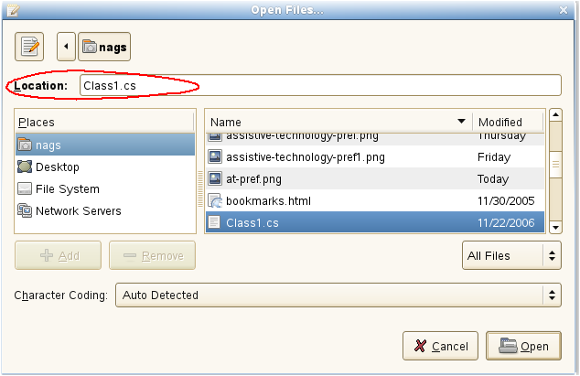

nags@nags:~> python
Python 2.5 (r25:51908, Nov 25 2006, 15:39:45)
[GCC 4.1.2 20061115 (prerelease) (SUSE Linux)] on linux2
Type "help", "copyright", "credits" or "license" for more information.
>>> from ldtp import *
>>> settextvalue ('dlgOpenFiles...', 'txtLocation', 'Class1.cs')
1
>>>

Table control
To select a row from the table of GTK open file selector, we need to collect information like, Window name (Open Files...), table name (Files – circled with blue color), row to be selected (Class1.cs).

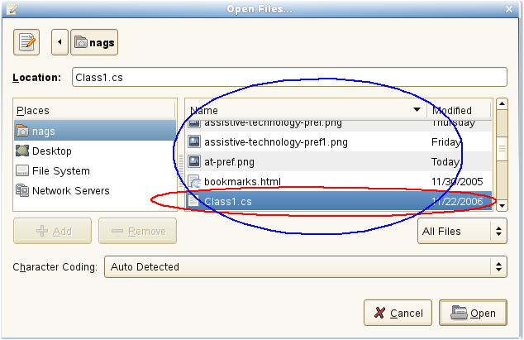
nags@nags:~> python
Python 2.5 (r25:51908, Nov 25 2006, 15:39:45)
[GCC 4.1.2 20061115 (prerelease) (SUSE Linux)] on linux2
Type "help", "copyright", "credits" or "license" for more information.
>>> from ldtp import *
>>> selectrow('dlgOpenFiles...', 'tblFiles', 'Class1.cs')
1
>>>

Push button
After selecting the file name, to open the file contents, we need to click on Open push button control. For doing this operation we need to gather informations like Window name (Open Files...), push button label name (Open).

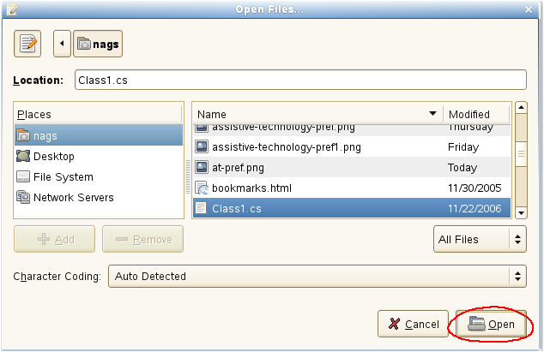
nags@nags:~> python
Python 2.5 (r25:51908, Nov 25 2006, 15:39:45)
[GCC 4.1.2 20061115 (prerelease) (SUSE Linux)] on linux2
Type "help", "copyright", "credits" or "license" for more information.
>>> from ldtp import *
>>> click ('dlgOpenFiles...', 'btnOpen')
1
>>>

Check box
To click on a check box control, we need to collect informations like window name (gedit Preferences), check box associated label name (Display line numbers).

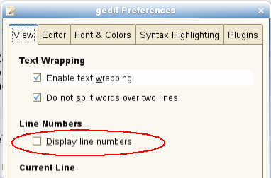

nags@nags:~> python
Python 2.5 (r25:51908, Nov 25 2006, 15:39:45)
[GCC 4.1.2 20061115 (prerelease) (SUSE Linux)] on linux2
Type "help", "copyright", "credits" or "license" for more information.
>>> from ldtp import *
>>> click ('dlggeditPreferences', 'chkDisplaylinenumbers')
1
>>>

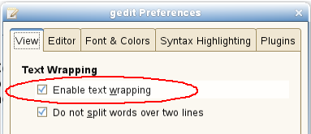

nags@nags:~> python
Python 2.5 (r25:51908, Nov 25 2006, 15:39:45)
[GCC 4.1.2 20061115 (prerelease) (SUSE Linux)] on linux2
Type "help", "copyright", "credits" or "license" for more information.
>>> from ldtp import *
>>> check ('dlggeditPreferences', 'chkEnabletextwrapping')
1
>>>

nags@nags:~> python
Python 2.5 (r25:51908, Nov 25 2006, 15:39:45)
[GCC 4.1.2 20061115 (prerelease) (SUSE Linux)] on linux2
Type "help", "copyright", "credits" or "license" for more information.
>>> from ldtp import *
>>> uncheck ('dlggeditPreferences', 'chkDisplaylinenumbers')
1
>>>

Spin button
To operate on a spin button, we need to collect information like Window name (gedit Preferences), spin button control name (Right margin at column).
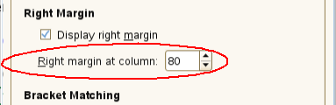

nags@nags:~> python
Python 2.5 (r25:51908, Nov 25 2006, 15:39:45)
[GCC 4.1.2 20061115 (prerelease) (SUSE Linux)] on linux2
Type "help", "copyright", "credits" or "license" for more information.
>>> from ldtp import *
>>> getvalue('dlggeditPreferences', 'sbtnRightmarginatcolumn')
80.0
>>> setvalue('dlggeditPreferences', 'sbtnRightmarginatcolumn', '81')
1
>>> setvalue('dlggeditPreferences', 'sbtnRightmarginatcolumn', '80')
1
>>>

Page tab
To operate on a page tab list, we need to collect information like window name (gedit Preferences), page tab list name (ptl0 in this case, as there are no label or associated label with this page tab list control), page tab name or index starting from 0.

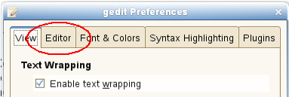

nags@nags:~> python
Python 2.5 (r25:51908, Nov 25 2006, 15:39:45)
[GCC 4.1.2 20061115 (prerelease) (SUSE Linux)] on linux2
Type "help", "copyright", "credits" or "license" for more information.
>>> from ldtp import *
>>> gettabcount ('dlggeditPreferences', 'ptl0')
5L
>>> selecttabindex ('dlggeditPreferences', 'ptl0', 2)
1
>>> selecttab ('dlggeditPreferences', 'ptl0', 'Editor')
1
>>>

Check menu item
To operate on check menu item, we need to gather information like window name (Unsaved Document 1 – gedit), menu name (View), check menu item name (Side Pane).

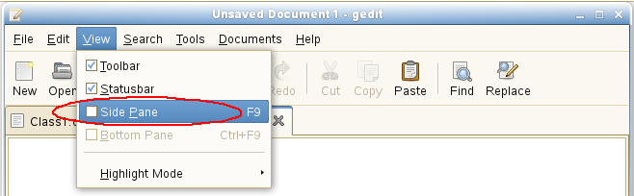
nags@nags:~> python
Python 2.5 (r25:51908, Nov 25 2006, 15:39:45)
[GCC 4.1.2 20061115 (prerelease) (SUSE Linux)] on linux2
Type "help", "copyright", "credits" or "license" for more information.
>>> from ldtp import *
>>> selectmenuitem ('*-gedit', 'mnuView;mnuSidePane')
1
>>> menuuncheck('*-gedit', 'mnuView;mnuSidePane')
1
>>>

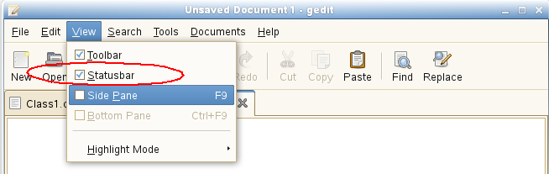

nags@nags:~> python
Python 2.5 (r25:51908, Nov 25 2006, 15:39:45)
[GCC 4.1.2 20061115 (prerelease) (SUSE Linux)] on linux2
Type "help", "copyright", "credits" or "license" for more information.
>>> from ldtp import *
>>> menucheck('*-gedit', 'mnuView;mnuStatusbar')
1
>>>

Radio menu item
To operate on a radio menu item control, we need to gather informations like window name (Unsaved Document 1 – gedit), menu name (Documents), menu item name (Class1.cs – assuming that Class1.cs is currently opened).

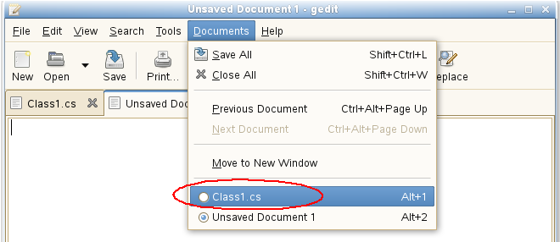

nags@nags:~> python
Python 2.5 (r25:51908, Nov 25 2006, 15:39:45)
[GCC 4.1.2 20061115 (prerelease) (SUSE Linux)] on linux2
Type "help", "copyright", "credits" or "license" for more information.
>>> from ldtp import *
>>> selectmenuitem ('*-gedit', 'mnuDocuments;mnuClass1.cs')
1
>>> menucheck ('*-gedit', 'mnuDocuments;mnuClass1.cs')
1
>>>

Combo box – Menu item
To select a menu item under a combo box, we need to gather informations like window name (Open Files...), combo box name (Character Coding), menu item name (Current Locale).

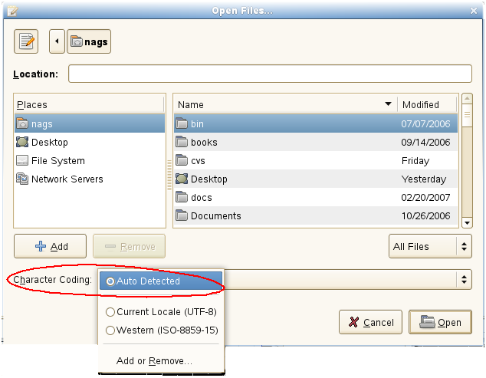

nags@nags:~> python
Python 2.5 (r25:51908, Nov 25 2006, 15:39:45)
[GCC 4.1.2 20061115 (prerelease) (SUSE Linux)] on linux2
Type "help", "copyright", "credits" or "license" for more information.
>>> from ldtp import *
>>> comboselect ('dlgOpenFiles...', 'cboCharacterCoding', 'Current Locale (UTF-8)')
1
>>>

Combo box – List item
To operate on list item under a combo box control, we need to gather informations like window name (Find), Combo box control name (Search for), list item existing content or list item index or new item name (OdbcMetaDataCollectionName.cs)

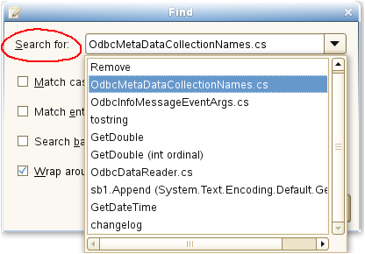

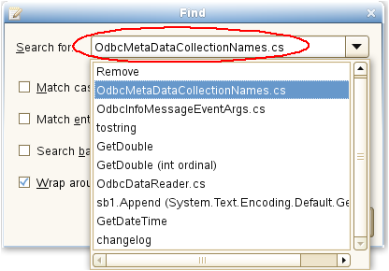

nags@nags:~> python
Python 2.5 (r25:51908, Nov 25 2006, 15:39:45)
[GCC 4.1.2 20061115 (prerelease) (SUSE Linux)] on linux2
Type "help", "copyright", "credits" or "license" for more information.
>>> from ldtp import *
>>> settextvalue('dlgFind', 'cboSearchfor', 'OdbcMetaDataCollectionNames.cs'')
1
>>>

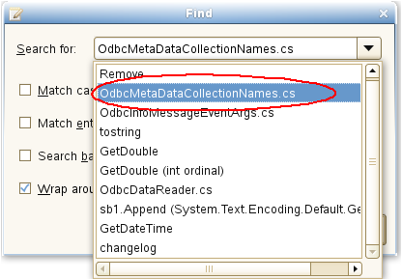

nags@nags:~> python
Python 2.5 (r25:51908, Nov 25 2006, 15:39:45)
[GCC 4.1.2 20061115 (prerelease) (SUSE Linux)] on linux2
Type "help", "copyright", "credits" or "license" for more information.
>>> from ldtp import *
>>> comboselect('dlgFind', 'cboSearchfor', 'OdbcMetaDataCollectionNames.cs')
1
>>>

Launch application
Application to be tested can be launched using LDTP API launchapp.

launchapp takes an optional argument, to set the environment variable GTK_MODULES and GNOME_ACCESSIBILITY and then invoke the respective application. When accessibility is not enabled by default in gnome-control-center, this is the preferred way of launching application.

nags@nags:~> python
Python 2.5 (r25:51908, Nov 25 2006, 15:39:45)
[GCC 4.1.2 20061115 (prerelease) (SUSE Linux)] on linux2
Type "help", "copyright", "credits" or "license" for more information.
>>> from ldtp import *
>>> launchapp ('gedit', 1)
1
>>>

Example 1
launcapp ('gedit')

Example 2
launchapp ('gedit', 1)

GUI exist
To check a GUI (window) exist, you can use this guiexist API. Also it has different flavors like waittillguiexist, waittillguinotexist.

- guiexist function checks whether the given window exists or not. If exist returns 1, else returns 0.
- waittillguiexist function will wait for the given window to appear. If appeared returns 1, else returns 0. Difference between guiexist and waittillguiexist is, guiexist returns immediately, but waittillguiexist will wait for a max of 30 seconds for a window to appear. Note: On doing some operation, if the expected result is, a window will be pop-ed up, then it is recommended to use waittillguiexist, instead of wait or sleep. Reason: wait or sleep will wait till the time period, but waittillguiexist, will return immediately once the window appears.
- waittillguinotexist function will wait for the given window to close. If closed returns 1, else returns 0. waittillguinotexist will wait for a max of 30 seconds for a window to close. Note: On doing some operation, if the expected result is, an existing window will be closed, then it is recommended to use waittillguinotexist, instead of wait or sleep. Reason: wait or sleep will wait till the time period, but waittillguinotexist, will return immediately once the window closed.

Timeout
GUI timeout

GUI timeout, is the default timeout settings used, by waittillguiexist and waittillguinotexist functions. This function will wait for the specified number of seconds, for the window to either appear or disappear. Default timeout period is 30 seconds.

This default timeout period that can be modified:

- By setting the environment variable GUI_TIMEOUT to whatever seconds.
- By passing a value to guiTimeOut argument of waittillguiexist or waittillguinotexist functions.
- By calling guitimeout function.
- When invoking LDTP engine, use -g option.

Example 1
export GUI_TIMEOUT=30

Example 2
waittillguiexist ('*-gedit', guiTimeOut=30)
waittillguinotexist ('dlgOpenFiles...', guiTimeOut=30)

Example 3
guitimeout (30)

Example 4
ldtp -g 30

OBJ timeout

OBJ timeout, is the default timeout settings used, internally. This function will wait for the specified number of seconds, for the object inside a window to appear. Default timeout period is 5 seconds.

This default timeout period that can be modified:

- By setting the environment variable OBJ_TIMEOUT to whatever seconds.
- By calling objtimeout function.
- When invoking LDTP engine, use -o option.

Example 1
export OBJ_TIMEOUT=5

Example 2
objtimeout (5)

Example 3
ldtp -o 5

Re-Initialize LDTP
When we open a new window in few applications, the windows accessibility informations are not updated, due to bug in the respective application (for example, Firefox 1.x or nautilus with GNOME 2.8). If we close the at-spi handle and re-open it, we will be able to get the accessibility information. That's where reinitldtp api will be useful.

nags@nags:~> python
Python 2.5 (r25:51908, Nov 25 2006, 15:39:45)
[GCC 4.1.2 20061115 (prerelease) (SUSE Linux)] on linux2
Type "help", "copyright", "credits" or "license" for more information.
>>> from ldtp import *
>>> launchapp ('firefox') # Firefox 1.5
1
>>> waittillguiexist ('*-MozillaFirefox')
1
>>> selectmenuitem ('*-MozillaFirefox', 'mnuEdit;mnuPreferences')
1
>>> reinitldtp ()
1
>>> waittillguiexist ('Preferences')
1

Set context / Release context
In some cases, the complete window title changes at run-time, setcontext can be used for such scenarios. For example, In Evolution application, the mail composer window's title changes dynamically, when the subject is typed. So, to access the window, after changing the subject, we need to change the window name (context name) for the consecutive calls. To over come this, we can use setcontext API and the rest of the call to the composer window can just have the same context name as the one before changing the subject.

nags@nags:~> python
Python 2.5 (r25:51908, Nov 25 2006, 15:39:45)
[GCC 4.1.2 20061115 (prerelease) (SUSE Linux)] on linux2
Type "help", "copyright", "credits" or "license" for more information.
>>> from ldtp import *
>>> selectmenuitem ('*-Evolution', 'mnuFile;mnuNew;mnuMailMessage')
1
>>> waittillguiexist ('frmComposeMessage')
1
>>> settextvalue ('frmComposeMessage', 'txtTo', 'ldtp-dev@lists.freedesktop.org')
1
>>> settextvalue ('frmComposeMessage', 'txtSubject', 'Testing set context')
1
>>> setcontext ('Compose Message', 'Testing set context')
1
>>> settextvalue ('frmComposeMessage', 'txt0', 'Body of the mail')
1

Generate raw keyboard events
In some cases, the window we are trying to operate may not be accessibility enabled or we may need to generate non-printable keys (ALT, CTRL, ENTER, BACKSPACE, ESC, F1-F12, SHIFT, CAPS LOCK, TAB, PAGE UP, PAGE DOWN, HOME, END, RIGHT / LEFT / UP / DOWN ARROW KEYS, INS, DEL). We can use generatekeyevent function or enterstring function to simulate the key events, as if the user typed. Note: All the non-printable characters will be enclosed with in angular brackets.
Example 1
<ctrl>lwww.google.co.in<enter>
Example 2
<alt><f1>
Example 3
<control>s

nags@nags:~> python
Python 2.5 (r25:51908, Nov 25 2006, 15:39:45)
[GCC 4.1.2 20061115 (prerelease) (SUSE Linux)] on linux2
Type "help", "copyright", "credits" or "license" for more information.
>>> from ldtp import *
>>> launchapp ('gedit')
1
>>> waittillguiexist ('*-gedit')
1
>>> enterstring ('<alt><tab>')
1
>>> enterstring ('*-gedit', 'txt0', '<caps>Testing enterstring API<enter>')
1
>>> generatekeyevent ('<alt><tab>')
1

Generate raw mouse events
To generate raw mouse events of different types like, b1c, b1d, b2c, b2d, b3c, b3d, X and Y of screen co-ordinates has to be provided. Here b is button, c is single click, d is double click.

nags@nags:~> python
Python 2.5 (r25:51908, Nov 25 2006, 15:39:45)
[GCC 4.1.2 20061115 (prerelease) (SUSE Linux)] on linux2
Type "help", "copyright", "credits" or "license" for more information.
>>> from ldtp import *
>>> generatemouseevent (100, 200) # Default is b1c
1
>>> generatemouseevent (100, 200, 'b1d')
1

Application information
On calling getapplist, will get all the accessibility application name that are currently running. To get window list for which the application map's are gathered and stored in local cache, use getwindowlist. To get all the object list under a window, use getobjectlist API. To get a list of properties available under an object, use getobjectinfo. To get the property of an object, use getobjectproperty.

nags@nags:~> python
Python 2.5 (r25:51908, Nov 25 2006, 15:39:45)
[GCC 4.1.2 20061115 (prerelease) (SUSE Linux)] on linux2
Type "help", "copyright", "credits" or "license" for more information.
>>> from ldtp import *
>>> getapplist ()
[u'gnome-session', u'gnome-power-manager', u'gnome-settings-daemon', u'Libbonoboui-Gtk-Module-init-info', u'nautilus', u'GnomeApplicationBrowser', u'/usr/lib/zen-updater/ZenUpdater.exe', u'gaim', u'gtk-window-decorator', u'gedit', u'xchat', u'gnome-panel', u'gnome-volume-manager', u'resapplet', u'nm-applet', u'soffice.bin']
>>> getwindowlist ()
[u'frmUnsavedDocument1-gedit']
>>> getobjectlist ('*-gedit')
...
>>> getobjectinfo ('*-gedit', 'btnNew')
[u'child_index', u'class', u'description', u'parent', u'label']
>>> getobjectproperty ('*-gedit', 'btnNew', 'class')
'New'

Callback – On new window creation
Register a callback event, when a window with given title is created. Glob type pattern can be given as title name.

Advantage
Unexpected window can be easily handled using this. For example, the password dialog box of Evolution, connection reset by peer dialog, application crash dialog, etc.

Example
from ldtp import *
import threading
callbackRunning = threading.Event ()
callbackRunning.clear ()
callbackState = threading.Event ()
callbackState.clear ()
def cb ():
callbackState.set ()
waittillguiexist ('dlgReplace')
click ('dlgReplace', 'btnClose')
callbackState.clear ()
callbackRunning.set ()
print 'callbackend'
onwindowcreate ('Replace', cb)
click ('*gedit', 'btnReplace')
click ('*gedit', 'btnOpen')
waittillguiexist ('dlgOpenFiles...')
click ('dlgOpenFiles...', 'btnClose')
if callbackState.isSet ():
print 'Waiting for callback to complete'
callbackRunning.wait ()
print 'callbackset'
print 'test end'

Color coding
Light yellow – Thread creation
Light green – Callback definition
Red – Callback registration
Magenta – General operation, which will invoke a window
Light blue – Wait for callback to complete, if invoked.

Logging
nags@nags:~> python
Python 2.5 (r25:51908, Nov 25 2006, 15:39:45)
[GCC 4.1.2 20061115 (prerelease) (SUSE Linux)] on linux2
Type "help", "copyright", "credits" or "license" for more information.
>>> from ldtp import *
>>> log ('test script', 'teststart')
1
>>> log ('test script', 'debug')
1
>>> log ('test script', 'warning')
1
>>> log ('test script', 'error')
1
>>> log ('test script', 'cause')
1
>>> log ('test script', 'commend')
1
>>> log ('group scripts', 'groupstart')
1
>>> log ('group scripts', 'groupstatus')
1
>>> log ('group scripts', 'groupend')
1
>>> log ('category scripts', 'categorystart')
1
>>> log ('category scripts', 'categorystatus')
1
>>> log ('category scripts', 'categoryend')
1
>>> log ('test script', 'pass')
1
>>> log ('test script', 'fail')
1
>>> log ('test script', 'testend')
1
>>>

Example script
from ldtp import *
from ldtputils import *

try:
logMsg = 'Open a file in gedit'
log (logMsg, 'teststart')
launchapp ('gedit')
if waittillguiexist ('*-gedit') == 0:
raise LdtpExecutionError ('Gedit window does not exist')
selectmenuitem ('*-gedit', 'mnuFile;mnuOpen')
if waittillguiexist ('dlgOpenFiles') == 0:
raise LdtpExecutionError ('Open Files dialog does not exist')
dataXml = LdtpDataFileParser (datafilename)
fileName = dataXml.gettagvalue ('filename')
selectrow ('dlgOpenFiles...', 'tblFiles', fileName [0])
click ('dlgOpenFiles...', 'btnOpen')
if waittillguinotexist ('dlgOpenFiles') == 0:
raise LdtpExecutionError ('Open Files dialog still exist')
log (logMsg, 'pass')
log (logMsg, 'testend')
except LdtpExecutionError, msg:
log (msg, 'cause')
log (logMsg, 'fail')
log (logMsg, 'testend')
raise LdtpExecutionError (logMsg)

Script input Data XML file - Useful to maintain a generic script

What
XML file contains input data required by the script at run-time.

Why
Scripts can be written generically and the data's required can be taken from this XML file.

Advantages of using LDTP Data XML
- Technically its a good practice to separate script and data. Reason behind this is re-usability
- Scripts will be written just once, based on the need we can just populate the data XML
- In some cases for doing regression testing we will just have one script and multiple data files
- Reason for XML format is, its easy to parse

LDTP Data XML Tags
We have the following tags in Data XML
- data - The complete XML are tagged under this <data> and </data> tag
- <user defined tags> - User defined tags with user defined values. These user defined tags can appear multiple times. If you use LDTP utils XML parser, the values from the user defined tags are returned as a list. So, you can use it with its index. The list index starts from 0.

Syntax
LdtpDataFileParser ('[XML Filename]')

LdtpDataFileParser class takes Data XML filename as an optional argument. This class also provides 2 functions.
- *setfilename ('[XML Filename]'). If the class does not takes an argument, then this function should be used
- * gettagvalue ('tag name'). Get the value of the given tag.

Example
Example 1
addr_book = LdtpDataFileParser ()
addr_book.setfilename ('evolution-ab.xml')
addr_book.gettagvalue ('AddressbookType')
Example 2
addr_book = LdtpDataFileParser ('evolution-ab.xml')
addr_book.gettagvalue ('AddressbookType')

Sample XML File
<data>
<AddressbookType>On This Computer<AddressbookType>

<AddressbookName>LDTP-AB</AddressbookName>
</data>

Sequencing set of LDTP scripts using ldtprunner XML file

What
XML file to group relevant scripts and respective data files under a group and execute them in one go.

Why
It will be useful, if we could group all the relevant test-case into one group and start executing them. If one of the test scripts fails under a group, then the execution of remaining scripts can be ignored.

Advantages of using ldtprunner XML
- Group set of related test-scripts into one category
- In a group if the current executing script fails, then rest of the scripts in the current group will be skipped and ldtprunner will start executing the next group
- Each individual scripts can take optional Data XML file as an argument
- Same script can be called multiple times with different Data XML file
- Scripts can be grouped in any sequence. Based on the sequence, scripts will be executed.

ldtprunner Tags
We have the following tags in ldtprunner XML
- ldtp - The complete XML are tagged under this <ldtp> and </ldtp> tag
- logfileoverwrite # - Value 0 (append to existing log file, if its already available) or 1 (Truncate the existing file, if its already available and write the data from 0)
- logfile - File name, where the log file has to be written. Log files are generated in XML format. Its preferred to give absolute path for the log file
- appmapfile # - Optinal application map file name. This option is available only for backward compatibility. We recommend not to use this option
- category # - A category can contain one or more group(s). All the group entries in a category will be executed in sequence. This feature was requested by Palm Source.
- group - A group can contain one or more scripts. All the scripts in a group will be executed in sequence. The purpose of group is, if one of the script fails, then the whole group is skipped
- testcaseid - One testcase id per group, if available will be logged as part of log file
- comment - Comments about the script, will not be logged in the log file
- script - Script contains one script file name and optional data file name
  - name - Script file name
  - data # - Data file name (Data file content will be in XML format - Data XML)
Note: # marked are optional fields
Following are the list of recommendations when generating ldtprunner XML
- Select the log file to initialize in ldtprunner XML
- Select log file overwrite option

Sample LDTP runner XML file
<?xml version="1.0"?>
<ldtp>
<logfileoverwrite>1</logfileoverwrite>
<logfile>evolutionexecutionstatus.xml</logfile>
<group>
<testcaseid>test-001</testcaseid>
<comment>testing script test1.py and test3.py</comment>
<script>
<name>test1.py</name>
<data>test1.xml</data>
</script>
<script>
<name>test3.py</name>
<data>test3.xml</data>
</script>
</group>
<group>
<script>
<name>test7.py</name>
<data>test2.xml</data>
</script>
</group>
</ldtp>

Color code
Green – LDTP runner XML tag
Light blue – Log file
Magenta – Group 1
Pale yellow – Group 2

How to execute LDTP scripts
Make sure that you have the following files in current working directory
- You need to have test scripts to be executed
- You can have Data XML - Optional
- You can have ldtprunner XML - Optional
- Make sure ldtp, ldtprunner, ltfx (optional), digwin (optional), ldtprecord (optional) are installed

Invoking LDTP runner XML
$ ldtprunner <ldtprunner XML>
Example
ldtprunner test-runner.xml

Invoking python script
$ python <script file name.py>
Example
python gedit.py

Suggestions from LDTP team
- When a new window is expected after an operation, its suggested to use waittillguiexist and on some operation, if a window is expected to close its suggested to use waittillguinotexist. In both cases, the time-out period is 30 seconds. This value can be modified – refer LDTP API reference.
- Use data XML file, the data XML file can be produced with different data and the script can be written once.

How to operate LDTP from a remote system

LDTP engine
Follow one of the options to start LDTP engine (ldtp binary) in the remote box
Option 1
$ldtp -s
Option 2
$ ldtp -p <port number to start> # Default port number is 23456

LDTP client
Follow one of the options in the client side to communicate to LDTP engine
Option 1
export LDTP_SERVER_ADDR=host-name or ip address
export LDTP_SERVER_PORT=<port number to communicate, as mentioned in LDTP engine>
python <script file name>.py or ldtprunner test-runner.xml
Option 2
export LDTP_SERVER_ADDR=host-name or ip address
python <script file name>.py or ldtprunner test-runner.xml # This will use default port number.

Troubleshooting LDTP
In-case, if you want to see whats happening on executing some LDTP commands, follow the steps

In a terminal

$ export LDTP_DEBUG=2 # If bash shell
$ ldtp
Client packet len: 82
i = 0
Data read 82, packet-len = 82, bytes read = 82, data: <?xml version="1.0"?><REQUEST><ACTION>124</ACTION><ID>MainThread124</ID></REQUEST>
PACKET LENGTH: 0
Received packet [<?xml version="1.0"?><REQUEST><ACTION>124</ACTION><ID>MainThread124</ID></REQUEST>] through 15
Node: ACTION
action_name: 124
Node: ID
request_id: MainThread124
Command: 124
Accessible application name: Thunderbird
Accessible application name: gnome-panel
Accessible application name: xchat
Accessible application name: nm-applet
Accessible application name: nautilus
Accessible application name: gaim
Accessible application name: acroread
Accessible application name: soffice.bin
Accessible application name: gtk-window-decorator
Accessible application name: gedit
LIST: <?xml version="1.0" encoding="utf-8"?><OBJECTLIST><OBJECT>nautilus</OBJECT><OBJECT>gaim</OBJECT><OBJECT>gtk-window-decorator</OBJECT><OBJECT>gedit</OBJECT><OBJECT>xchat</OBJECT><OBJECT>gnome-panel</OBJECT><OBJECT>Thunderbird</OBJECT><OBJECT>nm-applet</OBJECT><OBJECT>soffice.bin</OBJECT><OBJECT>acroread</OBJECT></OBJECTLIST>
resp_len = 117
Sending..
538
Response packet: <?xml version="1.0" encoding="utf-8"?><RESPONSE><ID>MainThread124</ID><STATUS><CODE>0</CODE><MESSAGE>Successfully completed</MESSAGE></STATUS><DATA><LENGTH>325</LENGTH><VALUE><![CDATA[<?xml version="1.0" encoding="utf-8"?><OBJECTLIST><OBJECT>nautilus</OBJECT><OBJECT>gaim</OBJECT><OBJECT>gtk-window-decorator</OBJECT><OBJECT>gedit</OBJECT><OBJECT>xchat</OBJECT><OBJECT>gnome-panel</OBJECT><OBJECT>Thunderbird</OBJECT><OBJECT>nm-applet</OBJECT><OBJECT>soffice.bin</OBJECT><OBJECT>acroread</OBJECT></OBJECTLIST>]]></VALUE></DATA></RESPONSE>
Msg:
Bytes sent: 542

In another terminal

$ export LDTP_DEBUG=2 # If bash
nags@nags:~> python
Python 2.5 (r25:51908, Nov 25 2006, 15:39:45)
[GCC 4.1.2 20061115 (prerelease) (SUSE Linux)] on linux2
Type "help", "copyright", "credits" or "license" for more information.
>>> from ldtp import *
>>> getapplist()
124 ( )
Send packet <?xml version="1.0"?><REQUEST><ACTION>124</ACTION><ID>MainThread124</ID></REQUEST>
Received packet size 538
Received response Packet <?xml version="1.0" encoding="utf-8"?><RESPONSE><ID>MainThread124</ID><STATUS><CODE>0</CODE><MESSAGE>Successfully completed</MESSAGE></STATUS><DATA><LENGTH>325</LENGTH><VALUE><![CDATA[<?xml version="1.0" encoding="utf-8"?><OBJECTLIST><OBJECT>nautilus</OBJECT><OBJECT>gaim</OBJECT><OBJECT>gtk-window-decorator</OBJECT><OBJECT>gedit</OBJECT><OBJECT>xchat</OBJECT><OBJECT>gnome-panel</OBJECT><OBJECT>Thunderbird</OBJECT><OBJECT>nm-applet</OBJECT><OBJECT>soffice.bin</OBJECT><OBJECT>acroread</OBJECT></OBJECTLIST>]]></VALUE></DATA></RESPONSE>
[u'nautilus', u'gaim', u'gtk-window-decorator', u'gedit', u'xchat', u'gnome-panel', u'Thunderbird', u'nm-applet', u'soffice.bin', u'acroread']
>>>

Sample LDTP script / runner XML / log XML

LDTP runner input XML file
<?xml version='1.0' encoding='utf-8'?>
<ldtp>
<category>
<!-- optional tag starts -->
<name>category1</name>
<!-- optional tag ends -->
<group>
<!-- optional tag starts -->
<name>group1</name>
<!-- optional tag ends -->
<script>
<name>file1.py</name>
</script>
</group>
</category>
</ldtp>

Test script
from ldtp import *
try:
log ('launch gedit','teststart')
launchapp ('gedit')
if waittillguiexist ('*-gedit') == 0:
raise LdtpExcecutionError ('Gedit window does not exist')
log ('launch gedit', 'pass')
except LdtpExecutionError, msg:
log (msg, 'cause')
log ('lauch gedit', 'fail')
log ('launch gedit', 'testend')
raise LdtpExecutionError ('launch gedit failed')
log ('launch gedit','testend')

XML Log file, On success
<?xml version='1.0' encoding='utf-8'?>
<ldtp>
<category name="category1">
<group name="group1">
<script name="launch-gedit.py">
<test name="launch gedit">
</test>
</script>
<pass>1</pass>
</group>
</category>
</ldtp>

XML Log file, On failure
<?xml version='1.0' encoding='utf-8'?>
<ldtp>
<category name="category1">
<group name="group1">
<script name="launch-gedit.py">
<test name="launch gedit">
<cause>window does not exist</cause>
</test>
</script>
<pass>0</pass>
</group>
</category>
</ldtp>

Bibliography
http://en.wikipedia.org/wiki/Software_testing
http://safsdev.sf.net

